**BASIC COMMANDS OF LINUX**

There are some of the basic commands used in Linux operating system:

1 man:

Show complete detail of a command

**Syntax:** man command_name

It is basically short form of manual and will tell you detail about other commands you pass to it as argument. It will explain you what that particular command do, how it work, what options it will take and so on. **Basically, if you remember name of any command, you can get all detail of it with man command.**

Example:

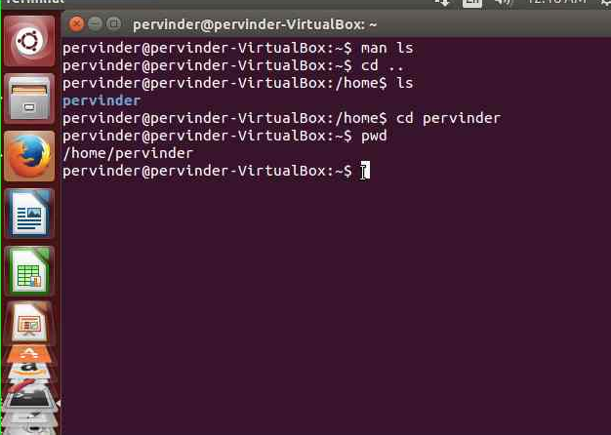

2 pwd:

Will print the current working directory

**Example:**

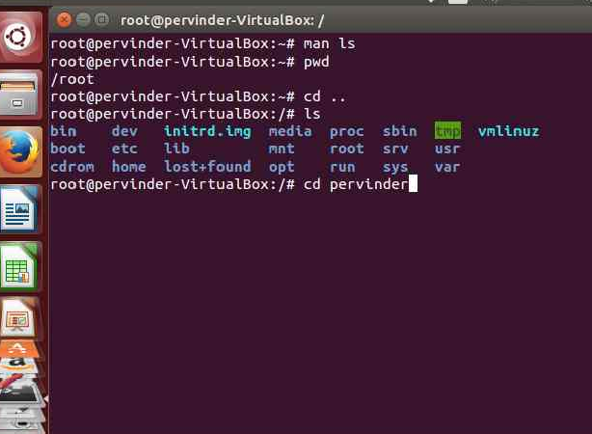

3 ls:

 Listing files and folders

Syntax: ls [options] #options are optional, if you do not pass it will take the default, you can see complete list of options with ls – -help.

Example:



4 more:

It can be also used to display content of a file on terminal.

Syntax: more [options] file_name # By default It do not provide scroll down facility like less to see the whole content but show only that much content which fit into your screen. However, using different options you can set the no of line you want to see, which will activate the scrolling if the set line not come on the screen.

Example:

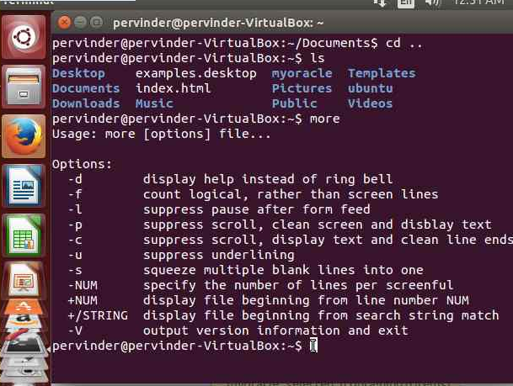

5 tcpdump:

Tcpdump prints out the headers of packets on a network interface that match the Boolean expression. It can also be run with the -w flag, which causes it to save the packet data to a file for later analysis, and/or with the -r flag, which causes it to read from a saved packet file rather than to read packets from a network interface. In all cases, only packets that match expression will be processed by tcpdump.

Syntax:

tcpdump [ -adeflnNOpqRStuvxX ] [ -c *count* ]  
  
[ -C *file_size* ] [ -F *file* ]  
  
[ -i *interface* ] [ -m *module* ] [ -r *file* ]  
  
[ -s *snaplen* ] [ -T *type* ] [ -U *user* ] [ -w *file* ]  
  
[ -E *algo:secret* ] [ *expression* ]

6 mv:

It will move file or directory to other location. If the location of source destination is same the file or directory will be get renamed

Syntax: mv [options] source destination

If two files are provided as source and destination source will be renamed as destination. If you pass more than two argument and the last one is directory all the previous will be treated as source and will be moved into the last directory, but if the last argument is not directory it will throw error.

Example: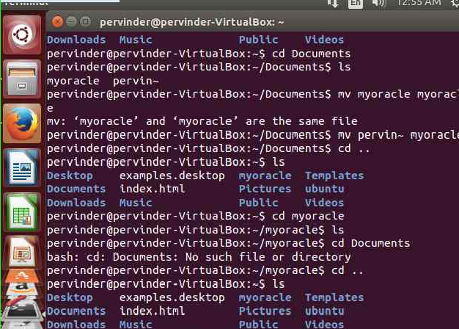

7 cp:

cp is a Linux shell command to copy files and directories.

Syntax:

Copy from source to dest

$ cp [options] source dest

Example:

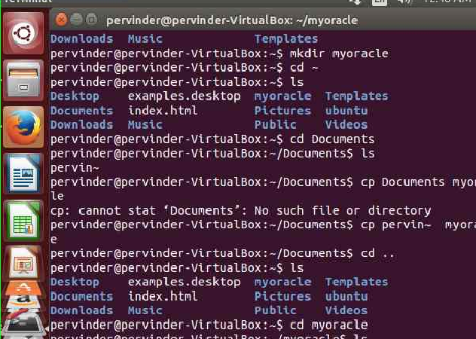

8 rm:

Removing file or folder, by default it remove only files to remove a folder, you need to pass additional options.

Syntax: rm [options] file_or_directory_name #options are optional, if you do not pass it will take the default, you can see list of options with rm – -help

Example:

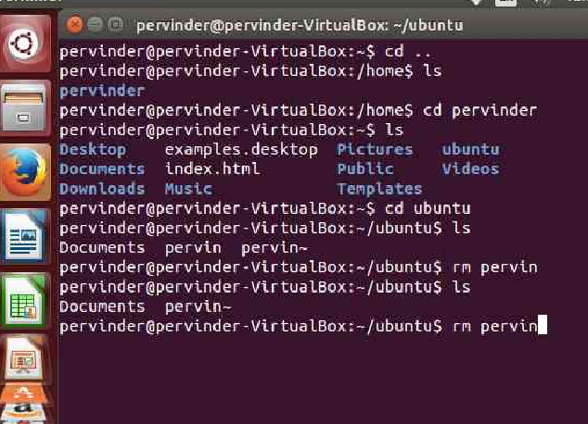

9 mkdir:

 Creating directory

Syntax: mkdir [options] directory_name #options are optional, if you do not pass it will take the default, you can see list of options with mkdir – -help.

Example:

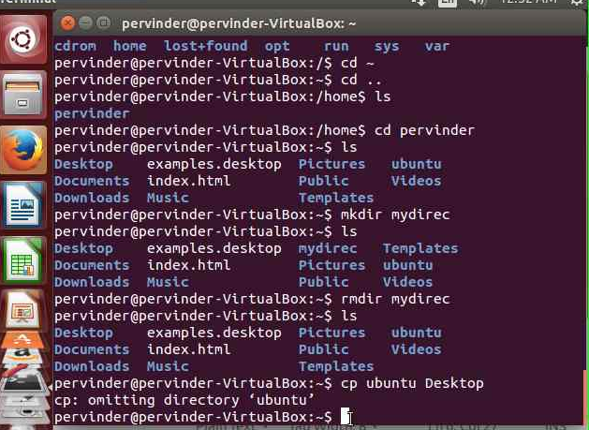

10 rmdir:

It will list empty directory

Syntax: rmdir [options] directory_name # without argument it will delete all empty directory name passed to it. It will throw error if directory is not empty. for that case use rm as above.

Example:



11 chmod:

The command name chmod stands for "change mode", and it is used to define the way a file can be accessed.

Syntax:

chmod *options* *permissions* *filename*

Example:

12 (p) kill:

Will kill the process passed to it

Syntax: pkill process_name # it would be helpful only if you know the name of process, you want to kill.

13 ping:

Ping is a simple way to send [network](http://www.computerhope.com/jargon/n/network.htm) data to, and receive network data from, another computer on a network. It is frequently used to test, at the most basic level, whether another [system](http://www.computerhope.com/jargon/s/system.htm) is reachable over a network, and if so, how much time it takes for that data to be exchanged.

The ping [utility](http://www.computerhope.com/jargon/u/utility.htm) uses the ICMP [protocol](http://www.computerhope.com/jargon/p/protocol.htm)'s mandatory ECHO_REQUEST [datagram](http://www.computerhope.com/jargon/p/packet.htm) to elicit an ICMP ECHO_RESPONSE from a [host](http://www.computerhope.com/jargon/h/hostcomp.htm) or [gateway](http://www.computerhope.com/jargon/g/gateway.htm). ECHO_REQUEST datagrams ("pings") have an [IP](http://www.computerhope.com/jargon/i/ip.htm) and ICMP [header](http://www.computerhope.com/jargon/h/header.htm), followed by a struct time Val and then an arbitrary number of "pad" [bytes](http://www.computerhope.com/jargon/p/pad.htm) used to fill out the packet.

Syntax:

ping [-LRUbdfnqrvVaAB] [-c *count*] [-m *mark*] [-i *interval*] [-l *preload*]

[-p *pattern*] [-s *packet size*] [-t *ttl*] [-w *deadline*] [-F *flowlabel*]

[-I *interface*] [-M *hint*] [-N *option*] [-Q *tos*] [-S *sndbuf*]

[-T *timestamp option*] [-W *timeout*] [*hop* ...] *destination*

14 cd:

Changing directory

Syntax: cd directory_name # you can pass directory_name or... Or ~ to cd

Example:

